**PROJECT REPORT**

**1.INTRODUCTION**

**1.1Overview**

Estimating business expenses is a crucial aspect of financial planning and management. It involves projecting the costs associated with running a business over a specific period of time, typically a month, quarter, or year. This process helps businesses allocate resources efficiently, make informed financial decisions, and assess the feasibility of their operations.

1. **Categorize Expenses**:

Start by categorizing expenses into fixed and variable categories. Fixed expenses remain relatively constant month-to-month (e.g., rent, insurance), while variable expenses fluctuate based on business activity (e.g., raw materials, utilities).

1. **Fixed Expenses**:

These are regular, predictable costs that do not change significantly regardless of business activity. Examples include:

* + - Rent or mortgage payments for office or retail space.
    - Insurance premiums (e.g., liability insurance, property insurance).
    - Salaries and wages (for permanent staff).
    - Loan repayments (e.g., equipment loans, lines of credit).

1. **Variable Expenses**:

These costs are tied to business activity levels and may vary from month to month. Examples include:

* + - Cost of goods sold (COGS) or cost of services delivered.
    - Utilities (electricity, water, gas).
    - Marketing and advertising expenses.
    - Travel and entertainment expenses.
    - Inventory purchases.

1. **Semi-Variable Expenses**:

Some expenses fall between fixed and variable. For example, salaries of part-time or temporary employees may vary based on business activity but are not entirely variable.

1. **One-Time Expenses**:

Account for any unusual or non-recurring expenses, such as equipment purchases, renovations, or legal fees.

1. **Estimating Variable Expenses**:

Use historical data or industry benchmarks to estimate variable expenses. For example, if you know that your business typically spends a certain percentage of revenue on marketing, you can use this as a guideline.

1. **Inflation and Price Changes**:

Take into account any anticipated changes in the cost of goods or services due to inflation or supplier price adjustments.

1. **Contingency and Miscellaneous**:

Include a buffer for unexpected or unforeseen expenses. This ensures you're prepared for any unforeseen circumstances.

1. **Tracking and Monitoring**:

Implement a system to track actual expenses and compare them to your estimates regularly. This allows for adjustments in your financial planning as needed.

1. **Cash Flow Considerations**:

Ensure that you have enough cash flow to cover your estimated expenses. This involves balancing the timing of revenue collection with expense payments.

1. **Review and Update**:

Regularly review and update your expense estimates based on changing business conditions, market trends, and any other relevant factors.

1. **Software and Tools**:

Consider using accounting software or expense management tools to streamline the process and provide more accurate tracking.

Remember, accurate expense estimation is crucial for financial stability and growth. It allows you to make informed decisions and ensures that you're adequately prepared to cover all your business costs.

**1.2 Purpose**

Estimating business expenses serves several important purposes, which are essential for effective financial management and decision-making. Here are some of the key purposes for estimating business expenses:

1. **Budgeting**: Estimating expenses is fundamental to creating a budget. A budget outlines projected revenue and expenses over a specific period, allowing businesses to allocate resources appropriately.
2. **Financial Planning**: It provides a roadmap for financial planning by helping businesses anticipate and prepare for upcoming financial obligations.
3. **Resource Allocation**: Helps in determining where and how to allocate financial resources. It allows for prioritizing spending based on the most critical needs of the business.
4. **Cost Control**: Enables businesses to monitor and control costs effectively. By having a clear estimate of expenses, businesses can identify areas where costs can be reduced or optimized.
5. **Profitability Assessment**: Helps in evaluating the potential profitability of a business venture. By estimating expenses alongside revenue projections, businesses can assess if a particular project or product line will be financially viable.
6. **Investment Decisions**: Assists in making informed investment decisions. Estimating expenses helps in determining the amount of capital required for a new project, expansion, or acquisition.
7. **Financial Projections and Forecasting**: Provides the basis for financial projections and forecasts. This is essential for planning for future growth and for attracting potential investors or lenders.
8. **Cash Flow Management**: Helps in managing cash flow effectively. By knowing when expenses are expected to occur, businesses can plan for adequate liquidity to cover their obligations.
9. **Risk Management**: Allows businesses to anticipate potential financial risks. By having a clear understanding of expected expenses, businesses can implement risk mitigation strategies or contingency plans.
10. **Negotiation and Vendor Management**: Provides a basis for negotiating contracts with vendors, suppliers, and service providers. Having a clear estimate of expenses helps in negotiating favorable terms and pricing.
11. **Performance Evaluation**: Allows for performance evaluation against budgeted expenses. This helps in identifying areas where actual expenses deviate from the estimates, enabling corrective actions to be taken.
12. **Compliance and Reporting**: Provides a foundation for compliance with financial reporting requirements. Accurate expense estimation is crucial for preparing financial statements and tax filings.
13. **Strategic Decision-Making**: Informs strategic decisions such as pricing strategies, product development, and market expansion. Knowing the expected expenses helps in setting realistic targets and objectives.
14. **Business Sustainability**: Contributes to the overall sustainability and longevity of the business. Accurate expense estimation ensures that the business can meet its financial obligations and remain solvent.

In summary, estimating business expenses is a critical component of financial management that supports various aspects of business operations. It aids in budgeting, financial planning, cost control, profitability assessment, and many other aspects that are essential for the success and sustainability of a business.

**2. PROBLEM DEFINITION AND DESIGN THINKING**

**2.1 Empathy Map**

An empathy map is a widely-used visualization tool within the field of UX and HCI practice. In relation to empathetic design, the primary purpose of an empathy map is to bridge the understanding of the end user.

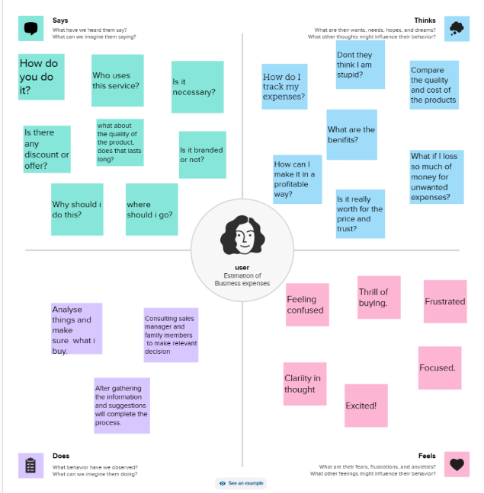

**2.2 Brainstorming Map**

Brainstorming map is a group creativity technique by which efforts are made to find a conclusion for a specific problem by gathering a list of ideas spontaneously contributed by its members.

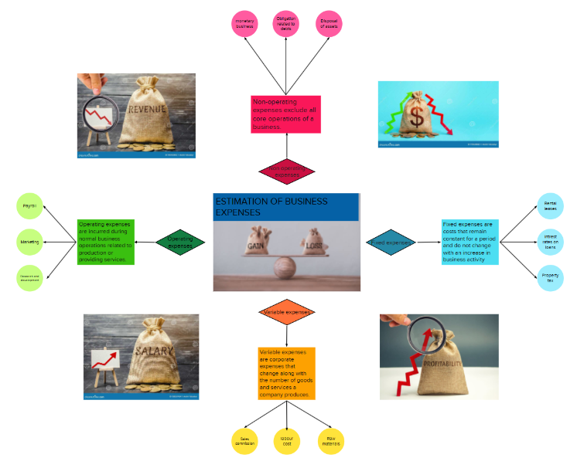

**3.RESULT**

**Dashboard:**

A dashboard is a graphical user interface (GUI) that displays information and data in an organized, easy-to-read format

**Dashboard 1:**

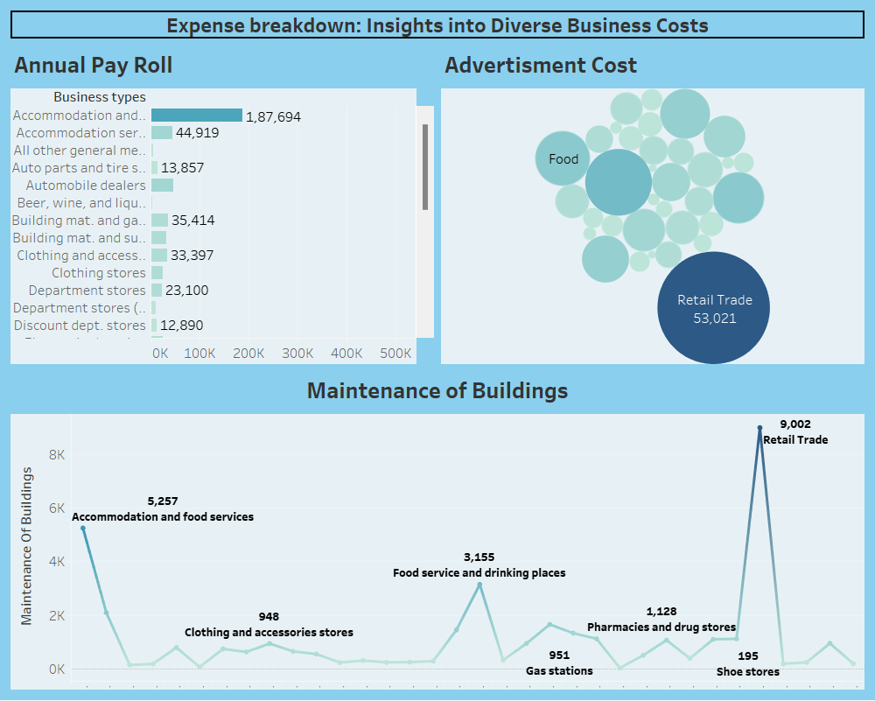

**Dashboard 2:**

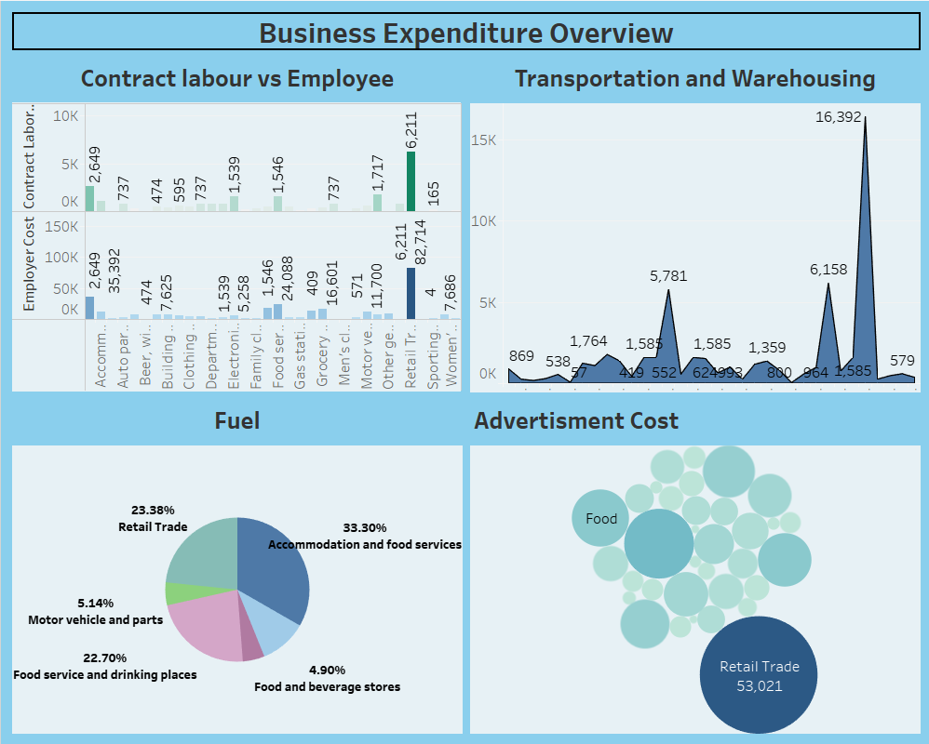

**Dashboard 3:**

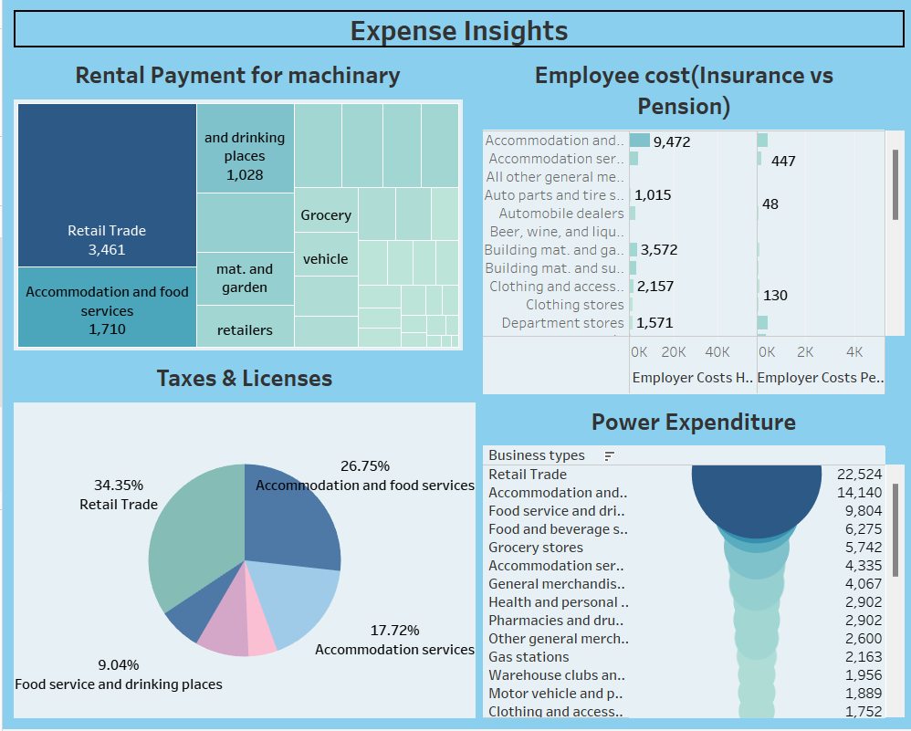

**Story line:**

A storyline is a way of presenting data and analysis in a narrative format, intending to make the information more engaging and easier to understand

**Story 1:**

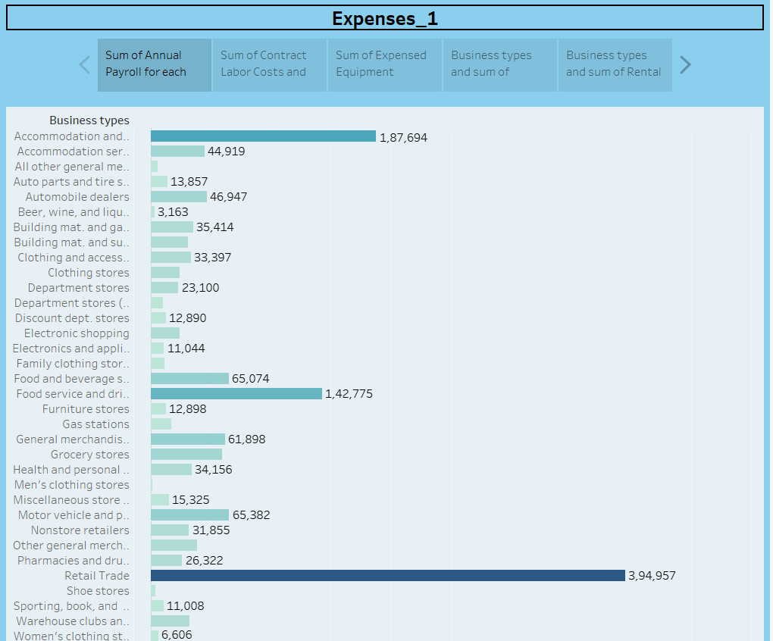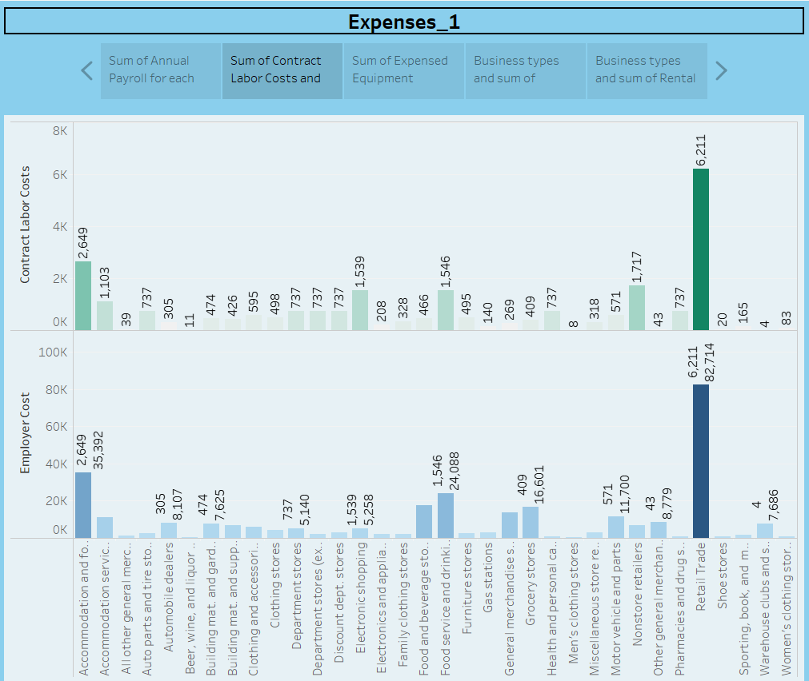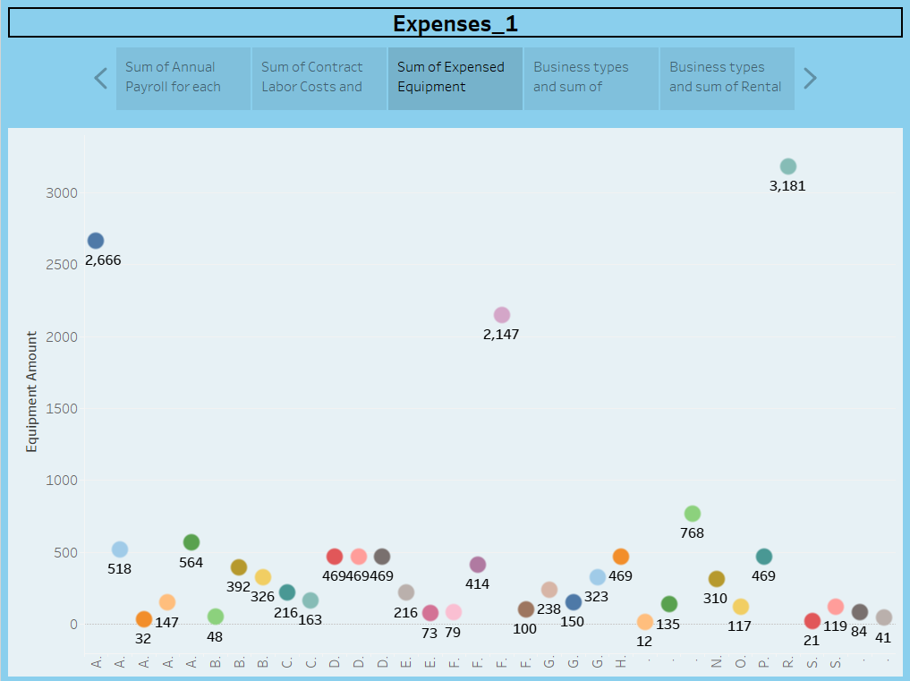

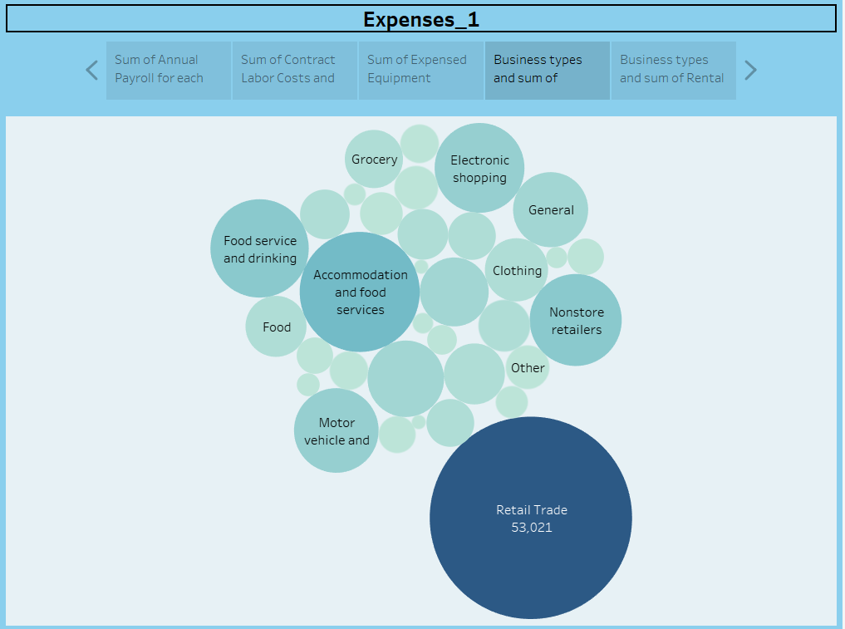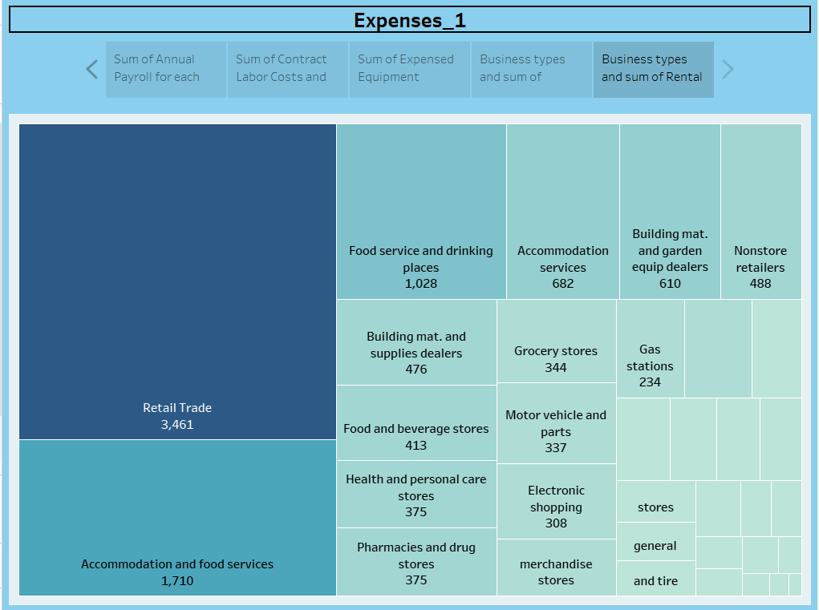

**Story 2:**

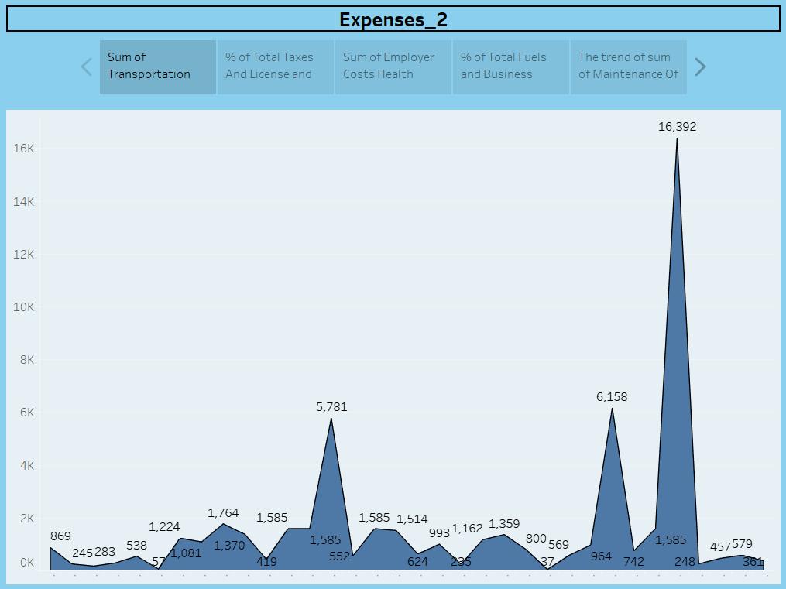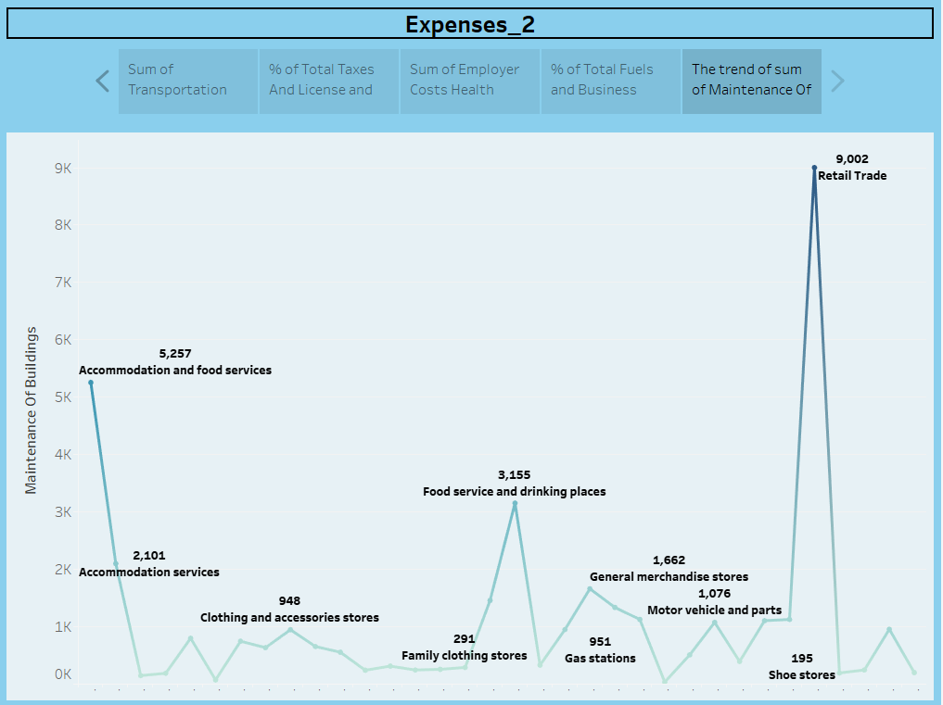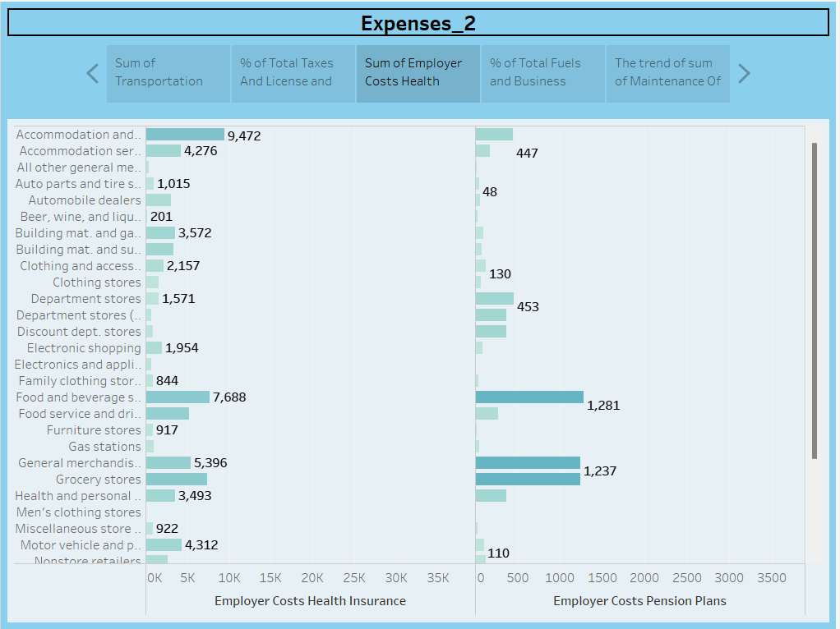

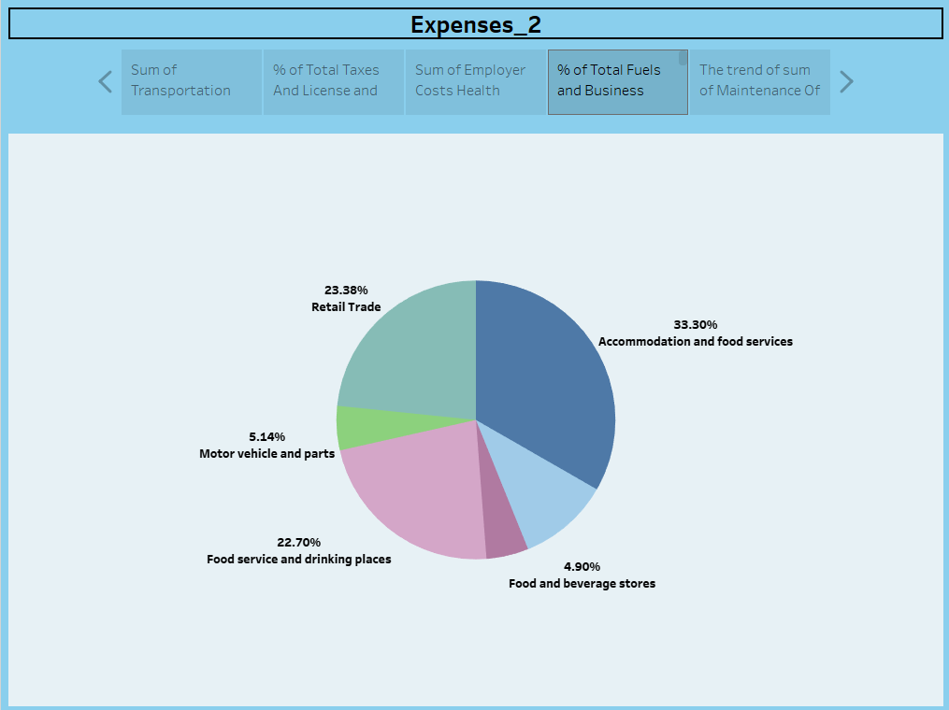

**4. ADVANTAGES AND DISADVANTAGES**

**Advantage**

Estimating business expenses offers several significant advantages for businesses of all sizes and industries. Here are some key advantages:

1. **Budget Development**: Allows for the creation of a structured budget that outlines expected revenue and expenses. This helps in allocating resources effectively and ensures that there are adequate funds for all necessary activities.
2. **Financial Planning**: Provides a clear roadmap for financial planning. Businesses can anticipate and prepare for upcoming financial obligations, reducing the likelihood of financial surprises.
3. **Cost Control**: Enables businesses to monitor and control costs effectively. With accurate expense estimates, businesses can identify areas where costs can be reduced or optimized.
4. **Resource Allocation**: Helps in determining where and how to allocate financial resources. It allows for prioritizing spending based on the most critical needs of the business.
5. **Profitability Assessment**: Allows businesses to evaluate the potential profitability of a venture or project. By estimating expenses alongside revenue projections, businesses can assess if a particular endeavor will be financially viable.
6. **Risk Management**: Allows businesses to anticipate potential financial risks. Knowing expected expenses helps in implementing risk mitigation strategies or contingency plans.
7. **Investment Decisions**: Assists in making informed investment decisions. Estimating expenses helps in determining the amount of capital required for a new project, expansion, or acquisition.
8. **Cash Flow Management**: Helps in managing cash flow effectively. By knowing when expenses are expected to occur, businesses can plan for adequate liquidity to cover their obligations.
9. **Performance Evaluation**: Allows for performance evaluation against budgeted expenses. This helps in identifying areas where actual expenses deviate from the estimates, enabling corrective actions to be taken.
10. **Strategic Decision-Making**: Informs strategic decisions such as pricing strategies, product development, and market expansion. Knowing the expected expenses helps in setting realistic targets and objectives.
11. **Compliance and Reporting**: Provides a foundation for compliance with financial reporting requirements. Accurate expense estimation is crucial for preparing financial statements and tax filings.
12. **Negotiation and Vendor Management**: Provides a basis for negotiating contracts with vendors, suppliers, and service providers. Having a clear estimate of expenses helps in negotiating favorable terms and pricing.
13. **Business Sustainability**: Contributes to the overall sustainability and longevity of the business. Accurate expense estimation ensures that the business can meet its financial obligations and remain solvent.
14. **Improved Decision-Making**: Provides a solid foundation for decision-making at all levels of the organization. It helps in making informed choices about resource allocation, investments, and strategic initiatives.
15. **Investor and Lender Confidence**: When seeking external funding, accurate expense estimation demonstrates financial competence and transparency, which can instill confidence in potential investors or lenders.

In summary, estimating business expenses is a crucial aspect of financial management that supports various facets of business operations. It aids in budgeting, financial planning, cost control, profitability assessment, and many other aspects necessary for the success and sustainability of a business.

**Disadvantages:**

While estimating business expenses is a crucial aspect of financial planning, there are potential disadvantages and challenges that businesses should be aware of. These can include:

1. **Inaccuracy and Unforeseen Costs**: Estimations are inherently uncertain, and actual expenses may deviate significantly from projections. Unforeseen events or unexpected price fluctuations can lead to budget shortfalls.
2. **Overestimation or Underestimation**: It's possible to overestimate or underestimate expenses. Overestimation may lead to unnecessary budget constraints, while underestimation can result in financial strain or even insolvency.
3. **Changing Market Conditions**: Economic shifts, changes in market demand, or inflation can impact the actual costs of goods, services, and resources, potentially rendering initial estimates outdated.
4. **Uncertain Revenue Projections**: Accurate expense estimation often relies on accurate revenue projections. If revenue estimates are incorrect, it can lead to misjudgment of necessary expenses.
5. **Inflexibility in Budget Allocation**: Rigidity in budget allocation can be a disadvantage. If unforeseen opportunities or challenges arise, the business might struggle to adapt if resources are tightly allocated.
6. **Neglect of Contingency Planning**: Over-reliance on estimates might lead to insufficient contingency planning. Sudden emergencies or unexpected events may strain the budget if there isn't a safety net.
7. **Difficulty in Estimating Variable Expenses**: Variable expenses are often more challenging to estimate accurately because they fluctuate with business activity levels. Relying on historical data or industry benchmarks may not always provide accurate projections.
8. **Time and Effort Intensive**: Creating accurate expense estimates requires time, effort, and often detailed financial analysis. Small businesses with limited resources may find this process particularly demanding.
9. **Overemphasis on Historical Data**: Relying solely on historical data for expense estimation might not account for changing business conditions, market trends, or new cost-saving opportunities.
10. **Unpredictable External Factors**: External factors like political changes, natural disasters, or shifts in global markets can significantly impact expenses, and these are often unpredictable.
11. **Dependence on Suppliers and Vendors**: Reliance on external suppliers and vendors can introduce variability in costs due to changes in their pricing, availability, or quality of goods and services.
12. **Difficulty in Allocating Overheads**: Allocating indirect costs like rent, utilities, or administrative expenses to specific products or projects can be challenging and may lead to imprecise expense estimates.
13. **Lack of Financial Expertise**: Inexperienced or untrained individuals involved in the estimation process may produce less accurate estimates, potentially leading to financial strain.
14. **Tendency to Cut Essential Costs**: In an effort to meet budget targets, there might be a tendency to cut costs that are essential for the long-term success and sustainability of the business.

It's important for businesses to be aware of these potential drawbacks and take steps to mitigate them. This might involve regular monitoring and adjustment of estimates, maintaining a contingency fund, seeking professional financial advice, and staying informed about market trends and economic conditions.

5.APPLICATIONS

Estimation of business expenses finds applications across various aspects of business operations and financial management. Here are some key applications:

1. **Budgeting and Financial Planning**:
   * Creating detailed budgets for specific periods (monthly, quarterly, annually) to allocate resources and plan for future financial obligations.
2. **Cost Control and Management**:
   * Monitoring and controlling costs to ensure they align with the budgeted amounts, thereby maximizing profitability.
3. **Cash Flow Management**:
   * Predicting and managing cash flow by estimating when expenses will occur and ensuring sufficient liquidity to cover them.
4. **Pricing Strategies**:
   * Determining product or service prices that cover production costs, desired profit margins, and competitive considerations.
5. **Investment Decisions**:
   * Assessing the financial feasibility of new projects, expansions, acquisitions, or other investments by estimating associated expenses.
6. **Resource Allocation**:
   * Allocating financial resources to different departments, projects, or activities based on their respective expense estimates.
7. **Performance Evaluation**:
   * Comparing actual expenses to budgeted expenses to evaluate the financial performance and efficiency of various business functions.
8. **Risk Assessment and Mitigation**:
   * Anticipating potential financial risks and uncertainties by estimating expenses and incorporating contingencies in financial planning.
9. **Vendor and Supplier Negotiation**:
   * Negotiating contracts with vendors, suppliers, and service providers based on accurate estimates of costs and service requirements.
10. **Financial Reporting and Compliance**:
    * Preparing financial statements, tax filings, and other compliance-related documents based on accurate expense estimates.
11. **Product Costing**:
    * Determining the total cost of producing or acquiring goods and services, which is essential for setting competitive prices and assessing profitability.
12. **Marketing and Advertising Planning**:
    * Budgeting for marketing campaigns, advertising efforts, and promotional activities based on estimated costs.
13. **Strategic Planning**:
    * Guiding long-term strategic decisions, such as market expansion, product development, and entry into new business lines.
14. **Contingency Planning**:
    * Establishing contingency plans to address unexpected expenses or economic downturns based on estimates of potential risks.
15. **Forecasting and Projections**:
    * Creating financial projections for future periods based on anticipated revenue and expense trends.
16. **Capital Expenditure Planning**:
    * Estimating expenses for major capital investments, such as equipment purchases or facility expansions.
17. **Sustainability and CSR Initiatives**:
    * Budgeting for sustainability efforts and corporate social responsibility (CSR) programs, which may include expenses related to environmental initiatives, community outreach, and ethical business practices.
18. **Cost-Benefit Analysis**:
    * Comparing the anticipated costs and benefits of different business strategies or initiatives to make informed decisions.

These applications demonstrate how estimating business expenses is fundamental to various aspects of financial management and decision-making, supporting the overall success and sustainability of a business.

**6.CONCLUSION:**

In conclusion, estimating business expenses is an indispensable practice for sound financial management and strategic decision-making. It forms the bedrock of effective budgeting, financial planning, and resource allocation. By anticipating and planning for upcoming financial obligations, businesses can navigate through uncertainties, control costs, and maximize profitability. Furthermore, accurate expense estimation is crucial for evaluating project feasibility, making informed investment decisions, and ensuring compliance with financial reporting requirements. While there are potential challenges and uncertainties associated with estimation, businesses can mitigate these risks through regular monitoring, contingency planning, and seeking expert financial advice. Overall, a well-executed estimation of business expenses is a cornerstone of business sustainability, ensuring that financial resources are judiciously utilized to drive growth and long-term success.

**7.FUTURE SCOPE:**

The future scope in the estimation of business expenses is likely to be influenced by several emerging trends and technologies. Here are some potential areas of growth and development:

1. **Advanced Data Analytics**:
   * The use of advanced analytics, including predictive modeling and machine learning, will enhance the accuracy of expense estimation. This will enable businesses to make more informed financial decisions.
2. **Artificial Intelligence (AI) and Automation**:
   * AI-powered tools and automation will play a significant role in streamlining the process of estimating expenses. This includes automating data collection, analysis, and generating forecasts.
3. **Blockchain Technology**:
   * Blockchain can enhance transparency and accountability in financial transactions, potentially revolutionizing expense tracking and reporting.
4. **Expense Management Software**:
   * Continued advancements in expense management software will offer more sophisticated features for tracking, categorizing, and analyzing expenses. Integration with accounting systems will further streamline financial processes.
5. **Real-time Expense Tracking**:
   * The ability to track expenses in real-time will become more prevalent, allowing businesses to respond quickly to changes in spending patterns.
6. **Augmented Reality (AR) and Virtual Reality (VR)**:
   * These technologies may find applications in expense visualization and management, particularly in industries where physical assets are central to operations.
7. **IoT and Smart Devices**:
   * Internet of Things (IoT) devices can provide real-time data on energy consumption, equipment usage, and other operational expenses, leading to more accurate estimates.
8. **Blockchain-Based Smart Contracts**:
   * Smart contracts can automate and verify expense-related transactions, reducing the need for intermediaries and enhancing efficiency.
9. **Environmental, Social, and Governance (ESG) Reporting**:
   * Growing emphasis on sustainability and responsible business practices will require businesses to account for expenses related to ESG initiatives.
10. **Regulatory Compliance and Reporting Tools**:
    * Software and tools that facilitate compliance with evolving financial regulations and reporting standards will become increasingly important.
11. **Cybersecurity Expenses**:
    * As cybersecurity threats continue to evolve, businesses will need to allocate resources for robust security measures and incident response plans.
12. **Green Technology Investments**:
    * With an increased focus on sustainability, businesses may allocate more resources towards adopting green technologies and practices, impacting expense estimation.
13. **Supply Chain Resilience**:
    * The estimation of expenses related to supply chain management will gain importance in light of disruptions caused by events like pandemics or geopolitical tensions.
14. **Remote Work Expenses**:
    * The continued prevalence of remote work may lead to a shift in expense estimation towards technology, communication tools, and cybersecurity for remote employees.
15. **Healthcare and Pandemic-related Expenses**:
    * Ongoing concerns about public health may necessitate continued investment in health and safety measures, impacting expense estimation in various industries.

In conclusion, the future of estimating business expenses holds exciting potential driven by technological advancements, regulatory changes, and shifts in business priorities. Businesses that embrace these trends and technologies are likely to benefit from more accurate, efficient, and strategic expense management.